SIMATS ENGINEERING
ASSESSMENT TOOL – 1
Course: Database Management Systems (CSA05)
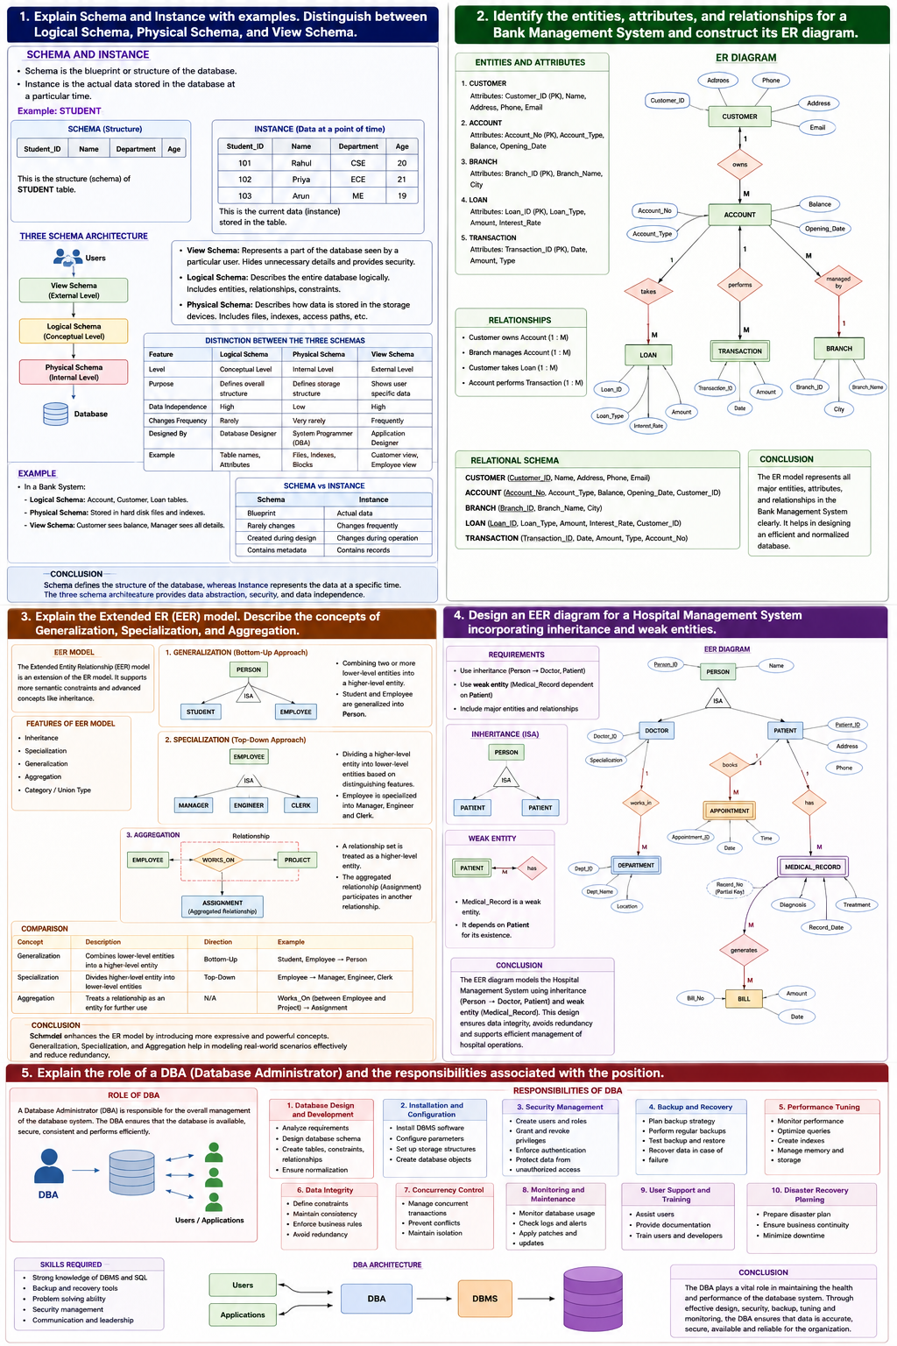
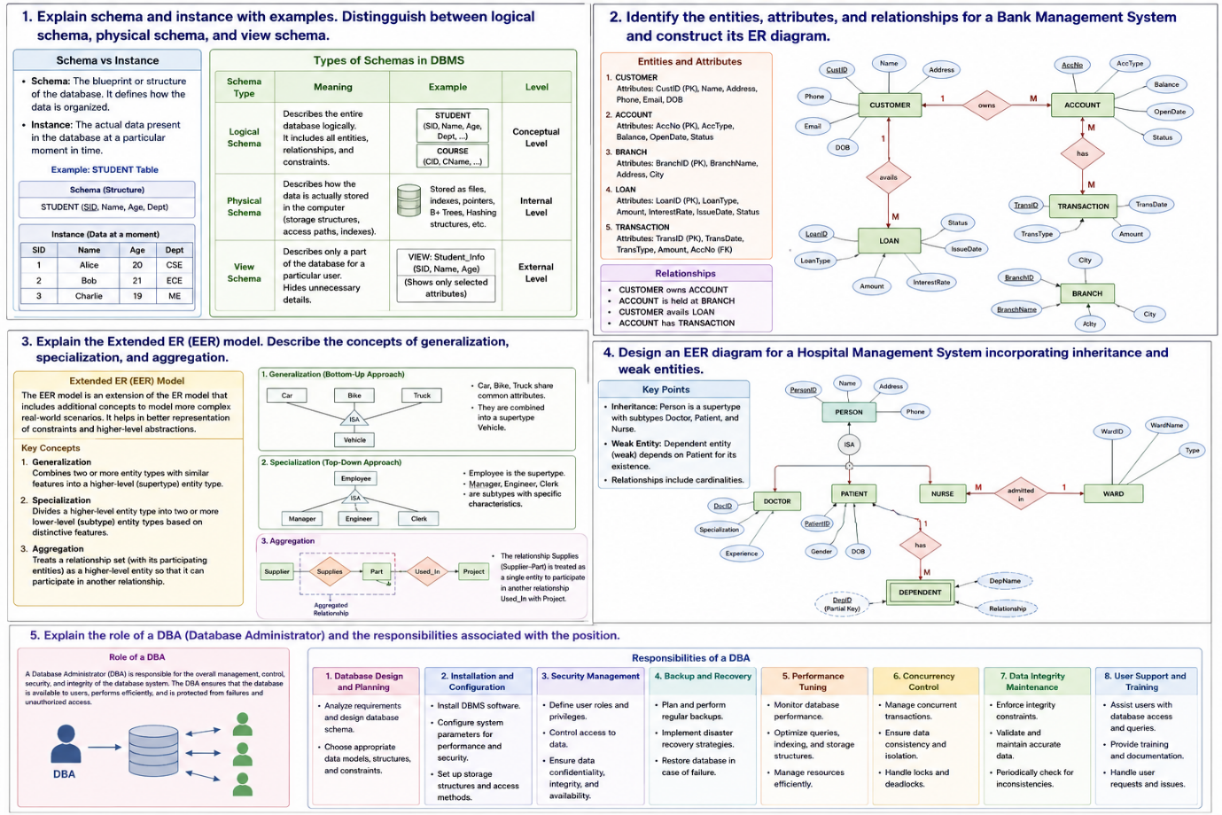 1
Explain Schema and Instance with examples. Distinguish between Logical Schema, Physical Schema, and View Schema.
Introduction
A Database Management System (DBMS) organizes and manages data efficiently. Two important concepts in DBMS are Schema and Instance. A schema defines the structure of the database, while an instance represents the actual data stored at a particular time.

What is Schema?
A Schema is the blueprint or design of the database. It specifies the tables, attributes, data types, relationships, and constraints but does not contain actual data.
Characteristics
- Defines database structure.
- Created during database design.
- Changes rarely.
- Independent of actual data.
Example
STUDENT Table Schema
Student_ID | Name | Department | Age
This represents only the structure.

What is Instance?
An Instance is the collection of actual records stored in the database at a specific point in time.
Example
Student_ID | Name | Department | Age
101 | Rahul | CSE | 20
102 | Priya | ECE | 21
If another student is added, the instance changes while the schema remains the same.

Schema vs Instance
Schema | Instance
Database structure | Actual data
Rarely changes | Changes frequently
Designed before implementation | Changes after insertion/update
Contains metadata | Contains records

Types of Schema
1. Logical Schema
Defines the logical organization of data such as tables, attributes, and relationships.
Example:
EMPLOYEE
-----------------------
Employee_ID (PK)
Employee_Name
Department
Salary
-----------------------

2. Physical Schema
Defines how data is physically stored inside storage devices.
Hard Disk
│
Employee File
│
Blocks
├── Block 1
├── Block 2
└── Block 3

3. View Schema
Shows only required information to a particular user.
DATABASE
│
┌────┼────┐
│ │ │
HR Manager Customer

Three Schema Architecture
Users
│
View Schema
│
Logical Schema
│
Physical Schema
│
Database

Example
In a banking system,
- Logical Schema → Account, Customer, Loan tables.
- Physical Schema → Stored in files and indexes.
- View Schema → Customer sees only account balance.

Conclusion
Schema defines the database structure, whereas Instance represents current data. Logical, Physical, and View Schemas provide different levels of abstraction, making databases secure, efficient, and easy to maintain.

Question 2
Identify the entities, attributes, and relationships for a Bank Management System and construct its ER Diagram.
Introduction
A Bank Management System stores information about customers, accounts, loans, branches, and transactions. The Entity Relationship (ER) Model is used to represent these components and their relationships.

Main Entities
CUSTOMER
Attributes
- Customer_ID (PK)
- Name
- Address
- Phone
- Email

ACCOUNT
Attributes
- Account_No (PK)
- Account_Type
- Balance
- Opening_Date

BRANCH
Attributes
- Branch_ID (PK)
- Branch_Name
- City

LOAN
Attributes
- Loan_ID (PK)
- Loan_Type
- Amount

TRANSACTION
Attributes
- Transaction_ID (PK)
- Date
- Amount
- Type

Relationships
Relationship | Cardinality
Customer owns Account | 1 : M
Branch manages Account | 1 : M
Customer takes Loan | 1 : M
Account performs Transaction | 1 : M

ER Diagram
CUSTOMER
+-------------------+
| Customer_ID (PK) |
| Name |
| Address |
| Phone |
+-------------------+
|
Owns (1:M)
|
V
ACCOUNT
+----------------------+
| Account_No (PK) |
| Account_Type |
| Balance |
+----------------------+
| |
Managed By Performs
(M:1) (1:M)
| |
V V
BRANCH TRANSACTION
+-----------+ +---------------+
|Branch_ID | |Transaction_ID |
|Branch_Name| |Date |
|City | |Amount |
+-----------+ |Type |
+---------------+

Customer
|
Takes (1:M)
|
V
LOAN
+-------------+
|Loan_ID (PK) |
|Loan_Type |
|Amount |
+-------------+

Relational Schema
CUSTOMER(Customer_ID, Name, Address, Phone)

ACCOUNT(Account_No, Account_Type, Balance, Customer_ID)

BRANCH(Branch_ID, Branch_Name, City)

LOAN(Loan_ID, Loan_Type, Amount, Customer_ID)

TRANSACTION(Transaction_ID, Date, Amount, Type, Account_No)

Advantages
- Eliminates redundancy.
- Maintains consistency.
- Easy data retrieval.
- Improves security.

Conclusion
The ER model clearly represents the entities, attributes, and relationships in a Bank Management System. It helps developers design an efficient and normalized database.

Question 3
Explain the Extended ER (EER) Model. Describe the concepts of Generalization, Specialization, and Aggregation.
Introduction
The Extended Entity Relationship (EER) Model is an extension of the ER model that supports advanced database design using inheritance and abstraction.

Features of EER Model
- Inheritance
- Specialization
- Generalization
- Aggregation
- Categories

Generalization
Generalization combines multiple lower-level entities into one higher-level entity.
Example
PERSON
▲
┌─────┴─────┐
│ │
Student Employee
Student and Employee are generalized into Person.

Specialization
Specialization divides one entity into multiple specialized entities.
Example
EMPLOYEE
│
┌────────┴────────┐
│ │
Manager Engineer
Each subclass inherits all attributes of Employee.

Aggregation
Aggregation represents a relationship as a higher-level entity.
Example
EMPLOYEE ---- Works_On ---- PROJECT
\ /
\_______________/
Assignment
Assignment can participate in another relationship.

Comparison
Concept | Description
Generalization | Bottom-up approach
Specialization | Top-down approach
Aggregation | Relationship treated as entity

Advantages
- Reduces redundancy.
- Supports inheritance.
- Improves scalability.
- Represents real-world scenarios.

Conclusion
The EER model extends the ER model by introducing inheritance and abstraction. Generalization, Specialization, and Aggregation simplify complex database designs.

Question 4
Design an EER Diagram for a Hospital Management System incorporating inheritance and weak entities.
Introduction
A Hospital Management System stores information about doctors, patients, appointments, rooms, medicines, and bills. The EER model helps represent inheritance and weak entities.

Main Entities
- Patient
- Doctor
- Appointment
- Department
- Bill
- Room

Inheritance
PERSON
/ \
DOCTOR PATIENT
Both Doctor and Patient inherit common attributes from Person.

Weak Entity
PATIENT
|
Has
|
MEDICAL_RECORD

Medical_Record depends on Patient.
Medical_Record cannot exist without Patient.

Hospital EER Diagram
PERSON
/ \
DOCTOR PATIENT
| |
Works In Has
| |
DEPARTMENT MEDICAL_RECORD
|
Generates
|
BILL

PATIENT ---- Books ---- APPOINTMENT ---- Consults ---- DOCTOR

Advantages
- Represents inheritance.
- Eliminates redundancy.
- Easy maintenance.
- Better data integrity.

Conclusion
The Hospital EER model accurately represents real-world hospital operations using inheritance and weak entities, making the database scalable and efficient.

Question 5
Explain the role of a DBA (Database Administrator) and the responsibilities associated with the position.
Introduction
A Database Administrator (DBA) is responsible for managing, maintaining, securing, and optimizing databases. The DBA ensures that data is available, accurate, and secure.

Role of DBA
A DBA manages the entire database lifecycle including installation, maintenance, security, backup, and performance optimization.

Responsibilities
1. Database Installation
- Install DBMS software.
- Configure databases.
2. Database Design
- Create tables.
- Define relationships.
- Normalize data.
3. Security Management
- Create users.
- Assign permissions.
- Prevent unauthorized access.
4. Backup and Recovery
- Schedule backups.
- Restore lost data.
- Maintain disaster recovery plans.
5. Performance Tuning
- Create indexes.
- Optimize queries.
- Monitor server performance.
6. Data Integrity
- Enforce constraints.
- Maintain consistency.
- Remove redundancy.
7. Monitoring
- Monitor storage.
- Monitor transactions.
- Monitor users.

DBA Architecture
DBA
│
┌──────────┼───────────┐
│ │ │
Security Backup Performance
│ │ │
Users Recovery Optimization
│
Database

Skills Required
Technical Skills | Soft Skills
SQL | Communication
DBMS | Problem Solving
Backup Tools | Decision Making
Security | Teamwork
Performance Tuning | Leadership

Advantages of DBA
- Ensures database security.
- Improves performance.
- Prevents data loss.
- Maintains availability.
- Supports business continuity.

Conclusion
A Database Administrator is one of the most important professionals in a DBMS environment. The DBA ensures data security, integrity, availability, and performance while managing backups, recovery, user access, and database optimization. Without a DBA, organizations may face data loss, security breaches, and poor database performance.

Overall Conclusion
Database Management Systems provide an organized approach to storing, managing, and retrieving data. Concepts such as Schema and Instance, ER Modeling, Extended ER Modeling, Hospital EER Design, and the Role of the Database Administrator (DBA) form the foundation of database design and administration. Together, these concepts help build reliable, secure, and scalable database systems used in banking, healthcare, education, and business applications. This assignment provides a comprehensive overview of these fundamental DBMS concepts in a structured, university-ready format suitable for submission.

